How does the system work?

The Inpatient – Admission Approval Form must be completed for all unscheduled, non-ED, non-scheduled requests. The following request types are supported (in this release):
- Inter Hospital Transfers
- Repatriation
- Home
- Clinic / Day Service Admission
- Day case, convert to inpatient

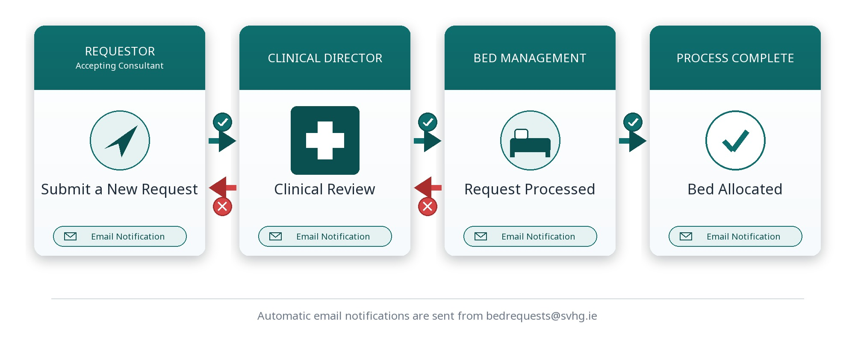
Once the request is submitted, it is routed to the appropriate Clinical Director for review, if approved the request is routed to bed management for processing. The system generates automatic email updates with outcomes from each step in the workflow, for example:

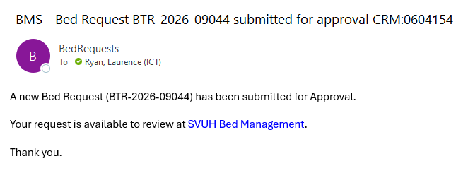

Before you begin:

- Supported browsers: Latest Chrome & Edge.
- Access: PCs and laptops must be connected to the St. Vincents (SVGH) network
- Email-domain: email updates and notifications are restricted to @svhg.ie addresses
  - Contact icthelpdesk@svhg.ie if you need an update email address.
- If the referring consultant is external to SVUH, they will not receive email updates and must be updated outside of the system, e.g. by phone.
- Timeouts: If left idle the clinical director, bed manager and dashboard work queues will timeout after 30 minutes and you will need to re login.
- The requestor and accepting consultant will receive automatic updates to their @svgh.ie email address.

How can I submit a request?
The Bed Management system can be accessed directly from you web browser by typing:
https://bms.svhg.ie/
To submit a new bed request, click “Submit a new request”
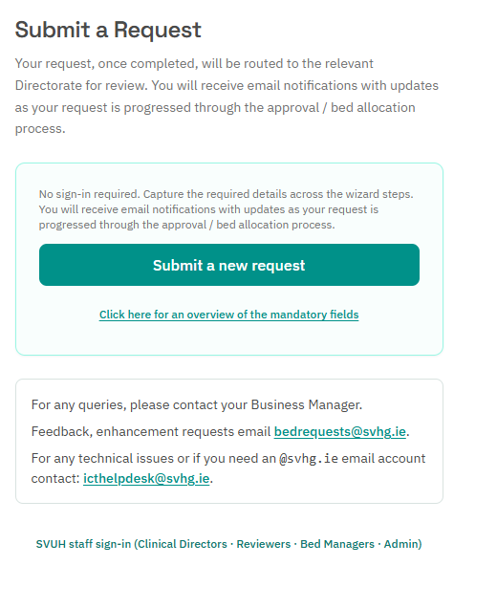

What is the minimum data set required to submit a request?
The following is a list of the mandatory fields required to submit a request.

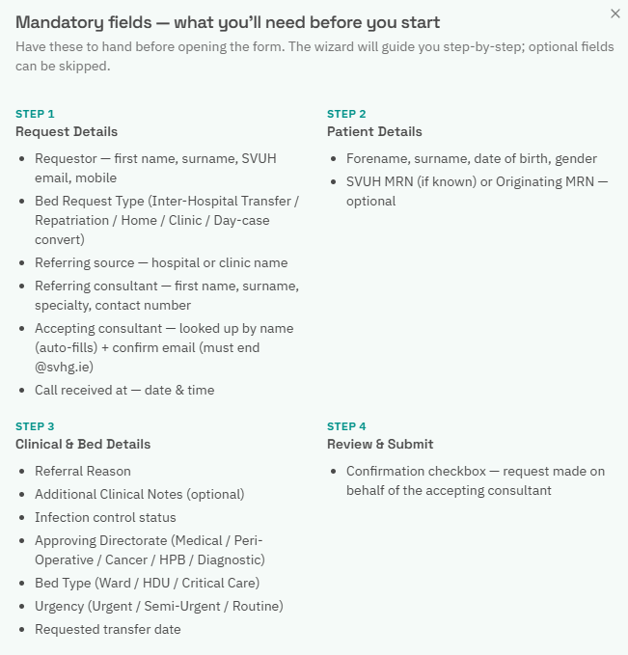

How do I complete the request form?

You will be guided through the completion steps, as follows

Step 1 – Request Details
Enter requestor details, request type and Accepting Consultant information. Ensure all mandatory fields are completed before pressing Continue to proceed. Only email addresses that end with svhg.ie, can be accepted by the system, for the requestor and accepting consultant. This email address will receive automatic updates as the request is processed.

Step 2 – Patient Information
Enter patient demographics and contact information. Ensure all mandatory fields are completed before pressing Continue to proceed.

Step 3 – Clinical & Bed Information
Enter referral reason and additional clinical notes. Select the appropriate Directorate and required bed type. Ensure all mandatory fields are completed before pressing Continue to proceed.

Step 4 – Review & Submit
Review all entered information. To amend any information, use the Back button to return to the relevant section and update the details. Tick the confirmation box before submitting the request.

How do I know my request was successfully created?
A confirmation message will be displayed with a unique request reference number. A status tracker will show the request process through each stage of the workflow (Submission, Clinical Review, Bed Allocation, Closure).

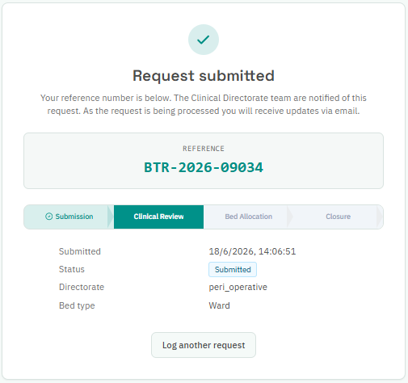

An automated email will also be sent to the requestor and accepting consultant confirming submission from bedrequests@svhg.ie and a link to monitor the request status tracker.

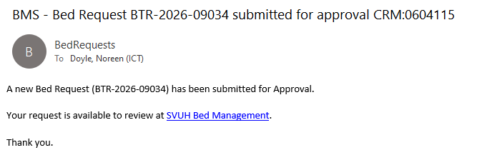

How can the Clinical Director access the system?
As a Clinical Director, access the system by following the link:
https://bms.svhg.ie/
Select the SVUH staff sign-in on link highlighted.
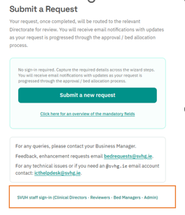
Select your Microsoft account to log in. (email address and password)
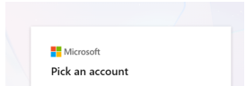

Once logged in your work queue is presented, to progress the request, select Triage
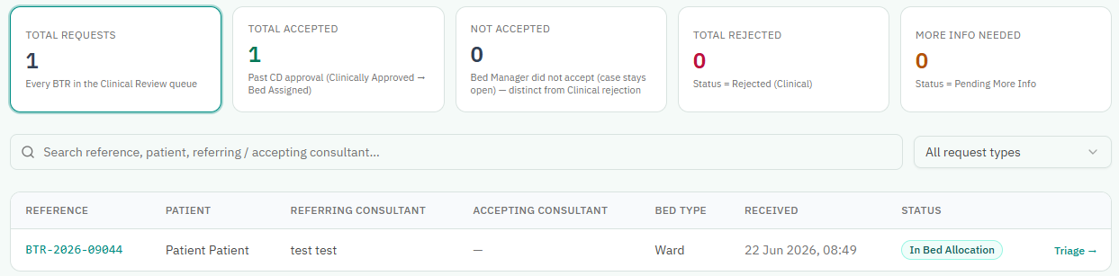

- Clinical Directors can access a request directly, by selecting the link in the email, when connected to the SVHG network. The links will not work if the device is not connected to the SVHG network. To access the system directly from your email link, the device must be connected to the SVHG network.

Triage
A clinical reason and outcome date must be entered for all triage decisions. An automated email notification is issued following each outcome, advising the relevant users of the decision and any required next steps. The following triage outcomes are available:
Accept
The request is approved and routed to the Bed Management queue for allocation.
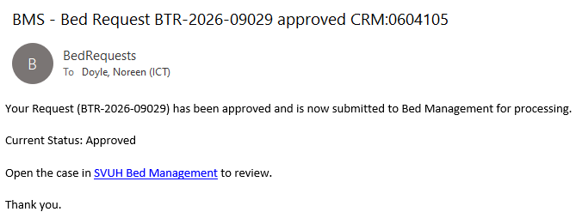
Reject
The request is declined, and the case is closed with a status update to rejected.
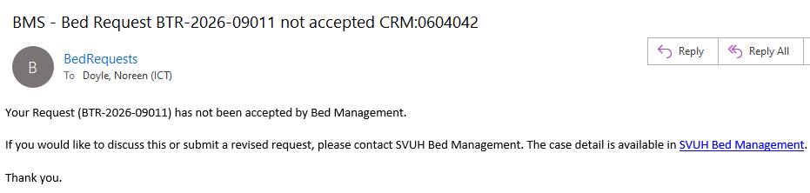
Additional Information Required
The request remains in the Clinical Review queue with a status of Pending More Information until further details are provided.

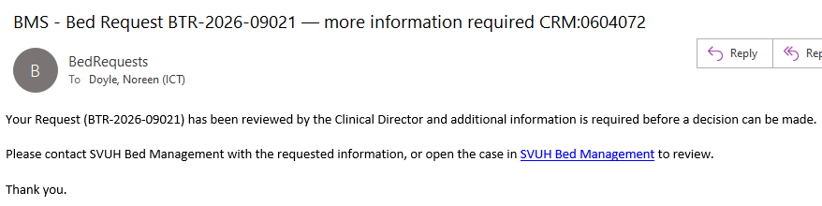

How can the Bed Manager access the system?

As a Bed Manager, access the system by following the link:
https://bms.svhg.ie/
Select the SVUH staff sign-in on link highlighted.
Select your Microsoft account to log in. (email address and password)

Approved requests are automatically routed to the Bed Manager Queue, where they are visible for bed allocation and ongoing management.

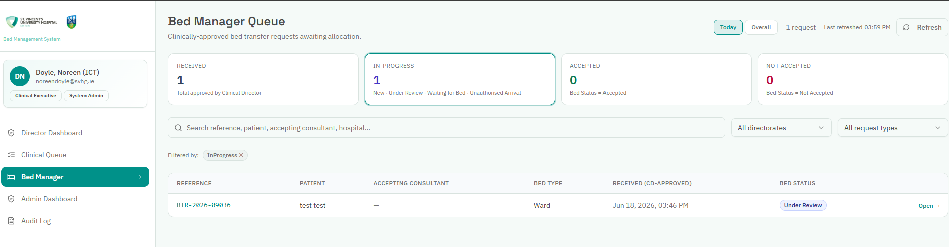
Click Open to view the bed request information and allocate a bed.
To update the status of the request, select “Save workflow Status”.

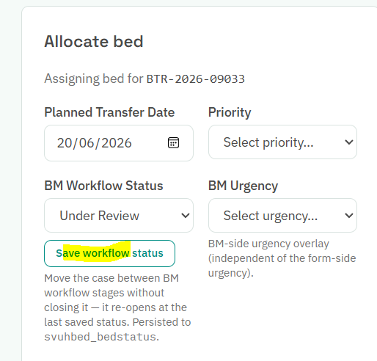
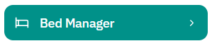
To navigate to the next request for processing, select the Bed Manager icon.
To close the case, complete the required allocation details and click Allocate Bed & Close
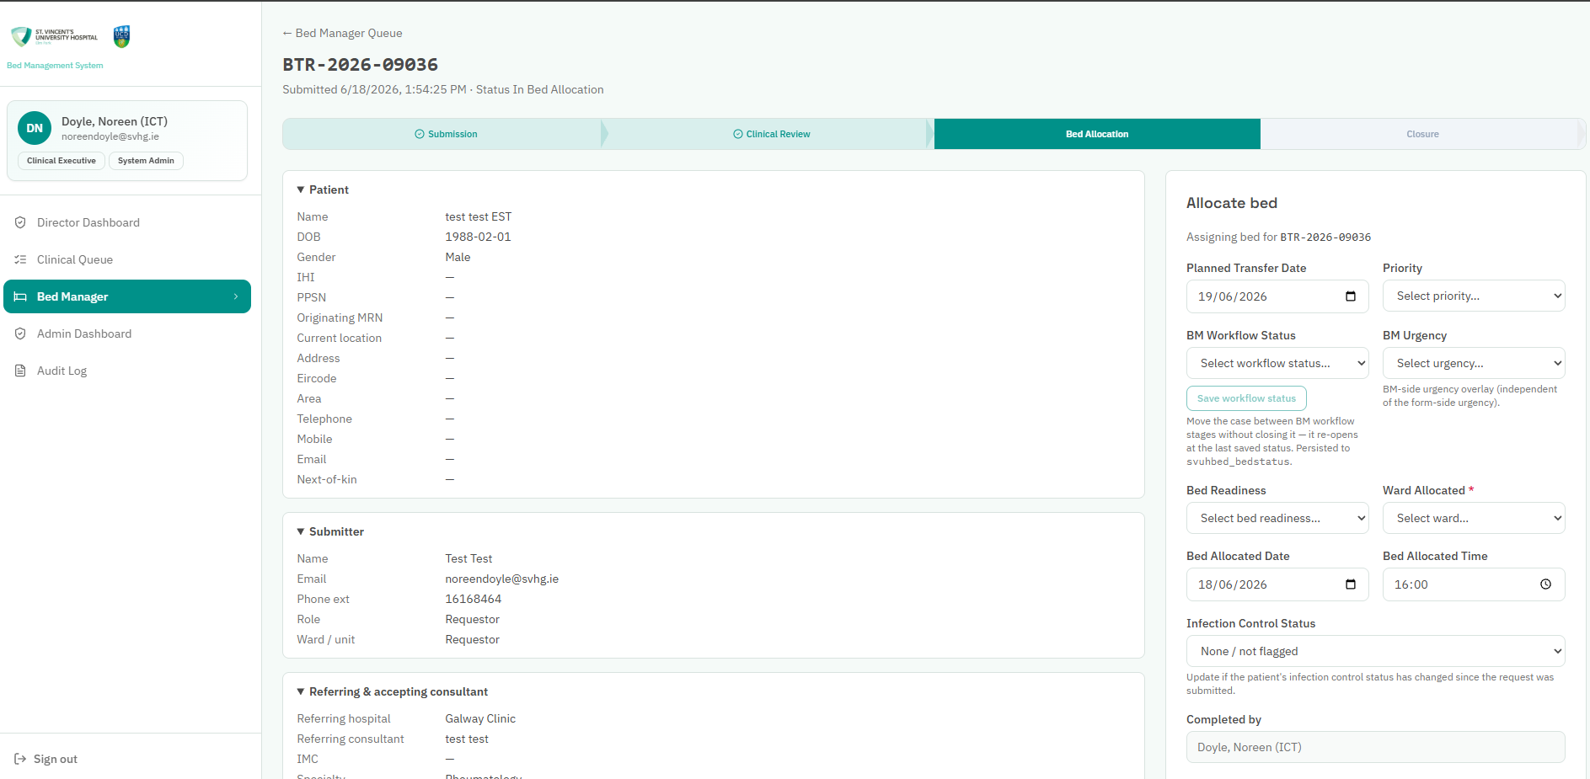

An automated email notification is sent when the bed is allocated.

